**DataBase Lab 2**

**21L-7512 Abdullah Dar BSCS-4G1**

**INSERT QUERY**

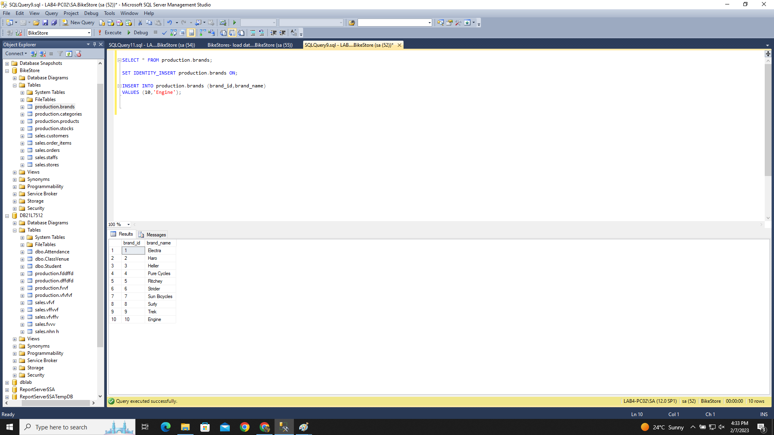

**DELETE QUERY**

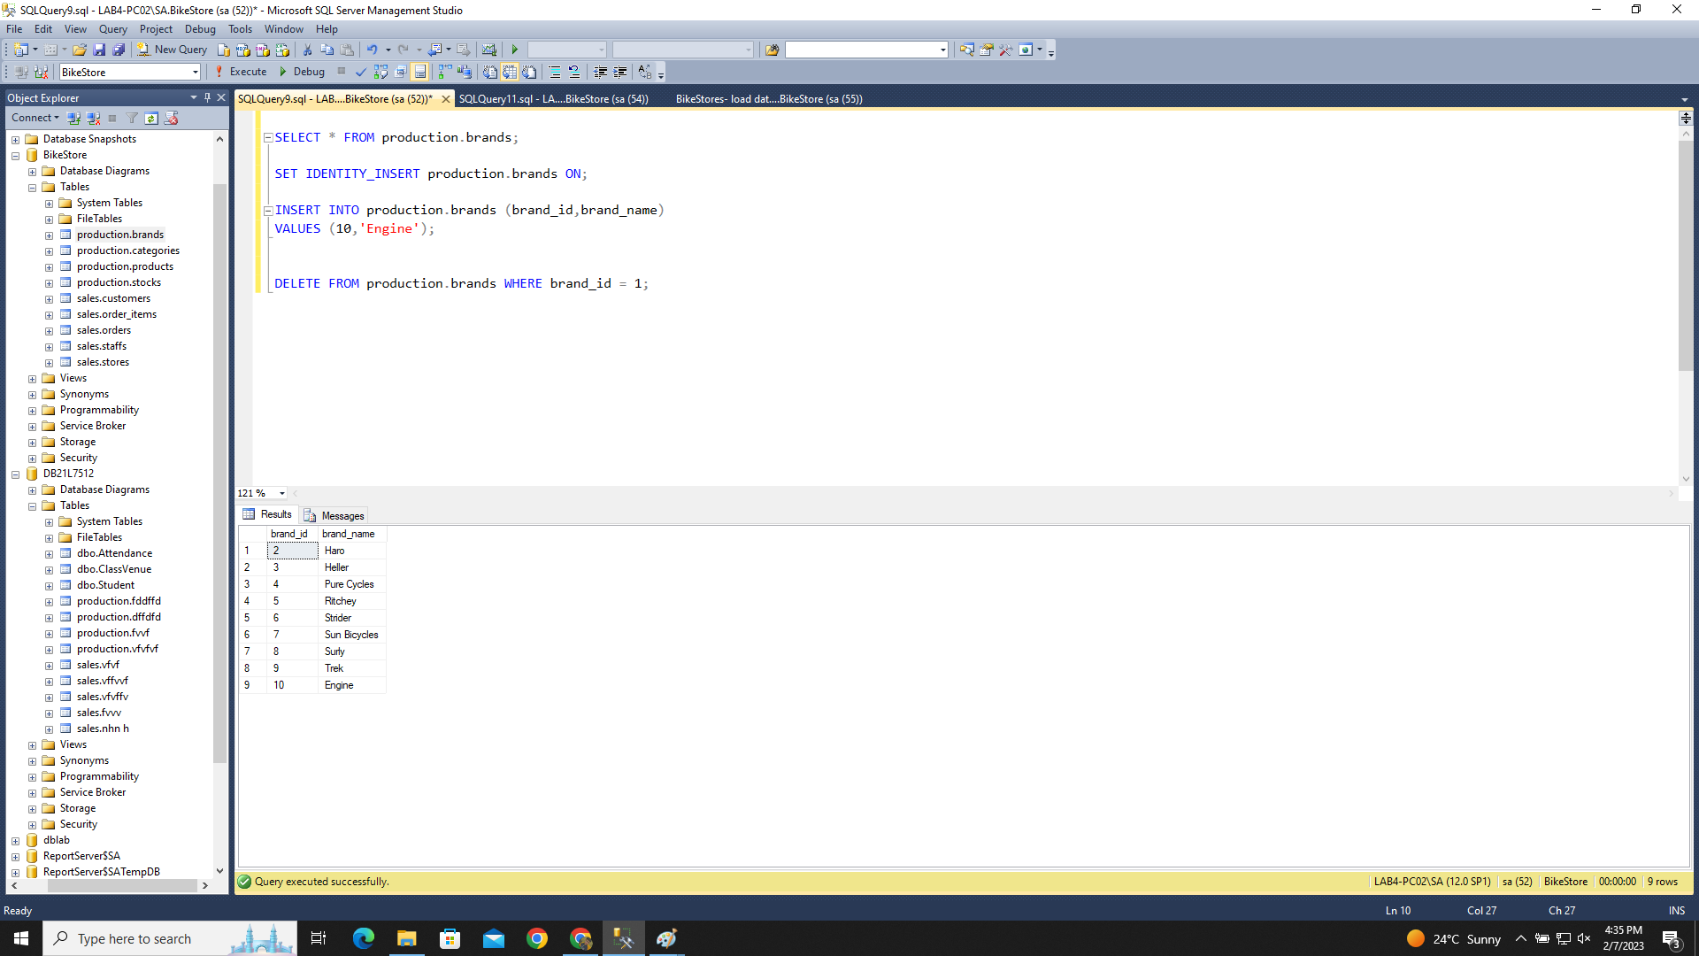

**UPDATE QUERY**

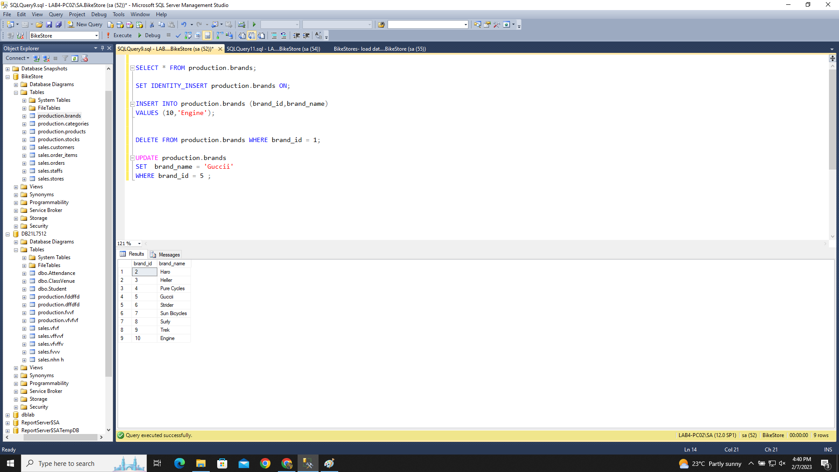

**SQL CODE**

SELECT * FROM production.brands;

SET IDENTITY_INSERT production.brands ON;

INSERT INTO production.brands (brand_id,brand_name)

VALUES (10,'Engine');

DELETE FROM production.brands WHERE brand_id = 1;

UPDATE production.brands

SET brand_name = 'Guccii'

WHERE brand_id = 5 ;